**Machine Learning by Andrew Ng, Stanford University on Coursera**

**Notes Part 1, Candice Ooi**

# Week 1 - Introduction Jan 30, 2020, March 10, 2020

*Welcome to Machine Learning! This week, we introduce the core idea of teaching a computer to learn concepts using data—without being explicitly programmed.*

*We are going to start by covering linear regression with one variable. Linear regression predicts a real-valued output based on an input value. We discuss the application of linear regression to housing price prediction, present the notion of a cost function, and introduce the gradient descent method for learning.*

*We’ll also have optional lessons that provide a refresher on linear algebra concepts. Basic understanding of linear algebra is necessary for the rest of the course, especially as we begin to cover models with multiple variables. If you feel confident in your understanding of linear algebra, feel free to take a break or help other students out in the forums.*

Definitions of Machine Learning

* Older and informal 1959: Arthur Samuel described it as: "the field of study that gives computers the ability to learn without being explicitly programmed."
* Modern: Tom Mitchell 1998: "A computer program is said to learn from experience E with respect to some class of tasks T and performance measure P, if its performance at tasks in T, as measured by P, improves with experience E."

Machine learning algorithms:

* Supervised learning
  + Right answers given.
  + E.g.: a regression problem – to predict a continuous valued output.
  + E.g.: a classification problem – to predict a discrete value output.
  + Support Vector Machine will allow you to deal with infinite number of features.
* Unsupervised learning
  + To find/derive structure in the dataset.
  + Approach problems with little or no idea what our results should look like.
  + Clustering algorithm
* Reinforcement learning
* Recommender Systems

Octave 2/Matlab open source programming environment

**LINEAR REGRESSION WITH ONE VARIABLE**

M = number of training samples

X = input variable/features

Y = output variable/ target variable

(x, y): one training example

(xi, yi) = ith row of training example

A list of m training examples (xi, yi); i = 1, …, m is a training set.

X to denote the space of input values, Y to denote the space of output value. X = Y = ℝ

Learning algorithm outputs a **hypothesis**, h, a function that takes input x and tries to output the estimated value y.

H is a function that maps from x to y. h : X → Y

hƟ(x) or h(x) = Ɵ0 + Ɵ1x, Ɵi is a parameter.

Univariate regression: linear regression with one variable

**Cost Function**

To measure the accuracy of our hypothesis function by calculating a fancier version of an average.

Minimization problem, to minimize Ɵ0 and Ɵ1.

The mean is halved as a convenience for the computation of the gradient descent, as the derivative term of the square function will cancel out the ½ term.

**Hypothesis function, is a function of x, Cost function, is a function of parameter.**

$y^{i}$ is the actual value on the chart, $h_{Ɵ}\left(x^{i}\right)$ is the predicted value on the chart. The difference is J.

**Choose the value of Ɵ1 that minimizes J(Ɵ1) the global minimum of the curve for the best fit of data.**

Plot Ɵ1 against J(Ɵ) if Ɵ0= 0. If not zero, Use Contour plots/figures to plot Ɵ1 and Ɵ0 against J(Ɵ), bowl shaped surface, a convex function – only has one global minimum.

A contour line of a two variable function has a constant value at all points of the same line.

Contour plots: points along the same contour has the same J(Ɵ0, Ɵ1). Minimum of the bowl is the cost function J.

**Gradient Descent**

**Gradient descent algorithm to minimize cost function J.** can minimize other functions as well.

Start with some Ɵ0 and Ɵ1, such as (0, 0) Keep changing until J is at the minimum.

Look around 360 degrees and find baby steps to go downhill as fast as possible, until converge to the local minimum. You will end up at different local minimum if you start at a different point.

**Repeat until convergence, while updating** Ɵj **simultaneously.**

**:= assignment operator.** A := B, set B to be the value of A.

**= truth assertion**. A = B. Claim that A and B is the same.

A:= A + 1, A = A + 1 is wrong.

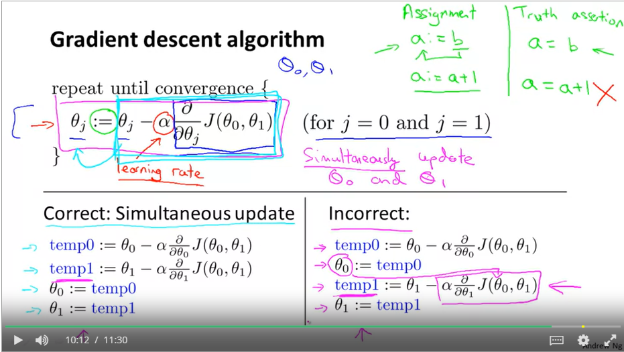

dJ(Ɵ)/d Ɵ is derivative to measure slope tangent to the function J(Ɵ).

Learning rate α is always a positive number. If α is too small, gradient descent can be slow. If α is too large, gradient descent can overshoot the minimum. It may fail to converge or even diverge, gets further and further away from the minimum.

Derivative is the slope tangent to the point. Global/local minimum when derivative = 0

If Ɵ1 is at the local minimum already, gradient descent will leave Ɵ1 unchanged.

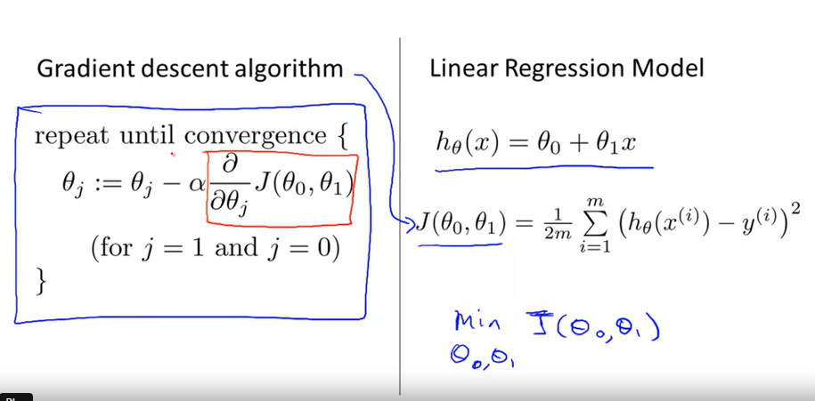Α can be fixed. As we approach the local minimum, gradient descent will automatically take smaller steps, the slope is getting smaller and smaller, so there is no need to decrease α over time.

**Gradient Descent for Linear Regression**

Linear regression algorithm is a combination of gradient descent and cost function.

Apply gradient descent to minimize cost function.

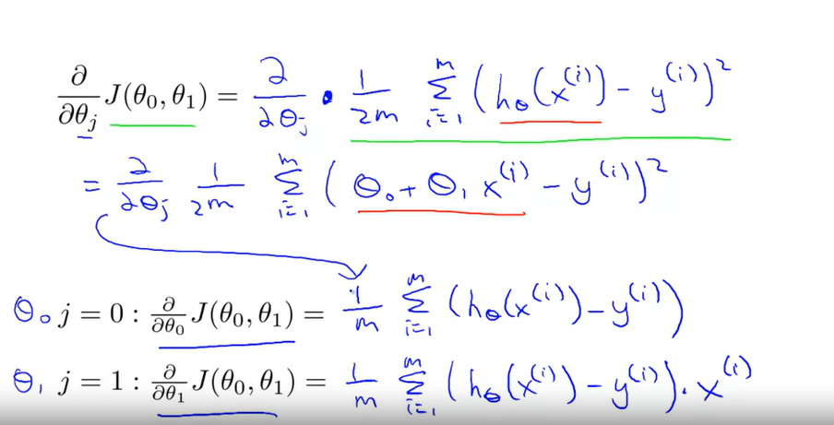

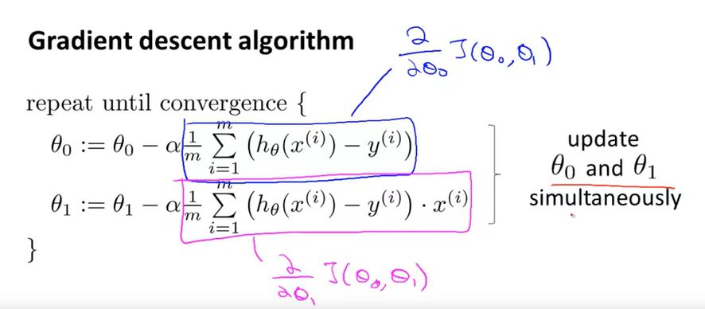

Downside of gradient descent is you can end up at a local minimum, not global.

Cost function of linear regression is always a convex function (bowl shaped), double derivative is positive. f’’(x) > 0

**Batch Gradient Descent**: each step of gradient descent uses all training examples.

Gradient descent scales better than normal equation method.

**Gradient descent to find cost.**

**LINEAR ALGEBRA REVIEW**

**Matrices and Vectors**

Matrix: rectangular array of numbers

Dimension of matrix: **number of rows x number of columns**

ℝrow x column

Aij = I,j entry in the ith row, jth column

Vector: a matrix that has only **one column**. An n x 1 matrix.

ℝrow

yi = ith element.

**1-indexed vector (most commonly used)** vs 0-indexed vector, first element starts at y1, or y0.

Most commonly,

* Upper case A, B, C to refer to matrices
* Lower case a, b, c, x, y to refer to real numbers, scalars or vectors

Matrix addition and subtraction can only be performed on matrix of the same dimension – same # rows and # columns.

**Matrix-vector multiplication**

**3** x 2 * 2 x **1** = **3 x 1**

Number of columns in matrix have to match number of rows in the vector, results into m-dimensional vector

Trick: to find h(x) given several x. prediction = data matrix * parameters. Use matrix to simplify code, instead of writing formulas. More computation efficient.

**Matrix-matrix multiplication**

2 x 3 * 3 x 2 = **2 x 2**

m x n matrix * n x o matrix = m x o matrix

number of columns in the first matrix must equal to number of rows in the second matrix.

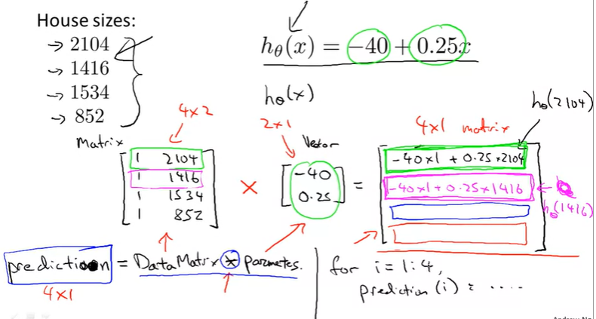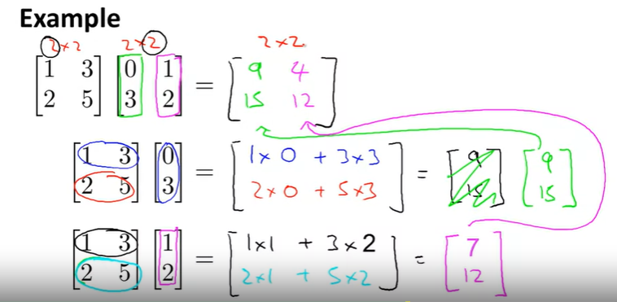

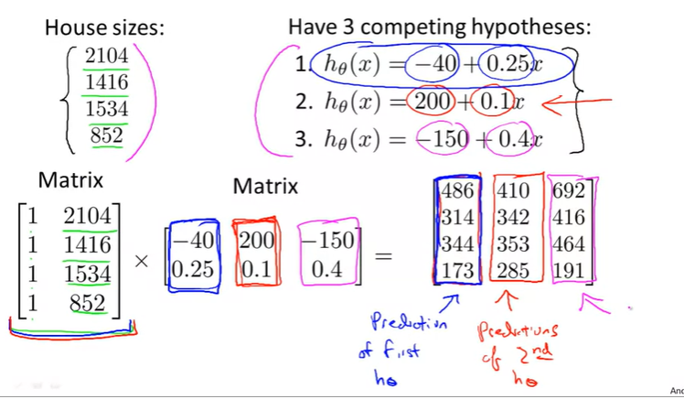

**Matrix Multiplication Properties**

* **Not commutative:** ordering of the matrix to multiply matters. A x B ≠ B x A , unless B is an identity matrix.
* **Associative:** A x B x C can be computed as (A x B) x C or A x (B x C)

Identity matrix I or I nxn

1 is identity of multiplication. 1 x z = z x 1 = z. 1 diagonally, 0 everywhere else.

A x I = I x A = A. I dimension has to match up.

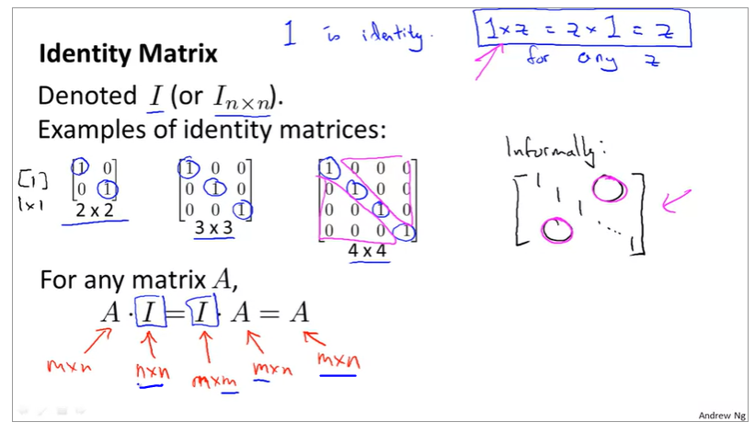

**Matrix Inverse and Transpose**

1 plays the role of the identity in the space of real numbers because one times anything is equal to itself.

3 * 3-1 = 1

0 does not have an inverse.

**If A is an m x m matrix, and if it has an inverse. AA-1 = A-1A = I, identity matrix.**

Only square matrices, m x m have inverses.

Zero matrix A, will not have an inverse. Matrices that don’t have an inverse are “singular” or “degenerate”.

Let A be an m x n matrix. B = AT.

Bij = Aji

# Week 2 – Linear Regression with Multiple Variables March 21, 2020

*Welcome to week 2! I hope everyone has been enjoying the course and learning a lot! This week we’re covering linear regression with multiple variables. we’ll show how linear regression can be extended to accommodate multiple input features. We also discuss best practices for implementing linear regression.*

*We’re also going to go over how to use Octave. You’ll work on programming assignments designed to help you understand how to implement the learning algorithms in practice. To complete the programming assignments, you will need to use Octave or MATLAB.*

**Make note of your assignment token listed on the exercise page, however, you will need it to submit your solutions.**

## Multivariate Linear Regression May 1, 2020

**Xj(i)** = input feature of feature j in ith training example

Recall: every row is a vector

Hypothesis: hƟ(x) or h(x) = Ɵ0 + Ɵ1x1 + Ɵ2x2 + … + Ɵnxn and xo = 1

think x and Ɵ as two column vector, indexed starting at 0.

**hƟ(x)** = Ɵ0x0 + Ɵ1x1 + Ɵ2x2 + … + Ɵnxn **= ƟTx**

ƟT is a row vector (n+1) x 1 matrix

**Gradient Descent for Multiple Variables**

$$J\left(Ɵ_{}\right)=\frac{1}{2}\overline{x}=\frac{1}{2m}\sum_{i=1}^{m}{{\left(\hat{y_{i}}- y^{i}\right)}^{2}}= \frac{1}{2m}\sum_{i=1}^{m}{{\left(h_{Ɵ}\left(x^{i}\right)- y^{i}\right)}^{2}= \frac{1}{2m}\sum_{i=1}^{m}{{\left(Ɵ^{T}\left(x^{i}\right)- y^{i}\right)}^{2} }}$$

where Ɵ is a nx1 matrix.

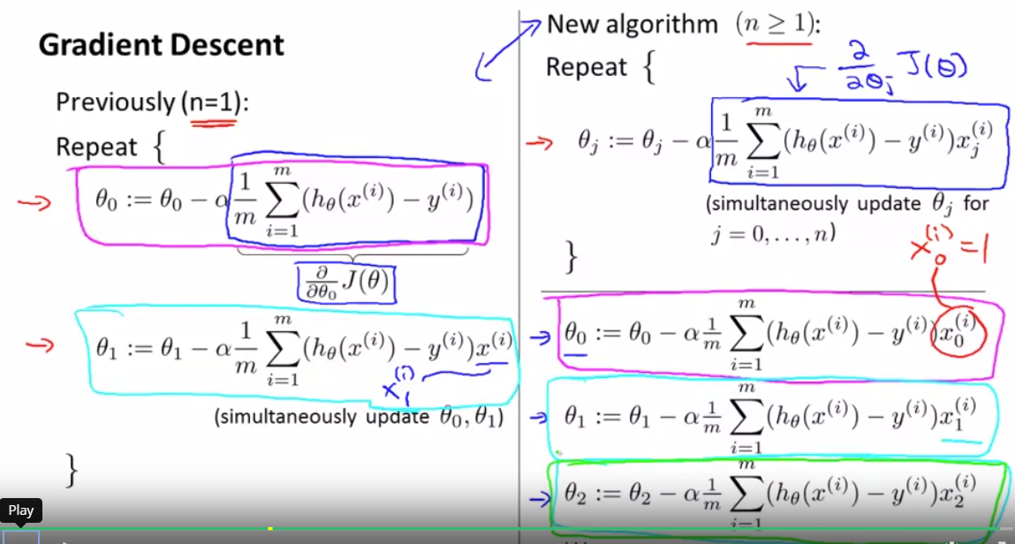

**Feature Scaling** to ensure features are in the same scale so that it converges more quickly, normalization. To get every feature, xi into the range of -1 and 1. To make sure gradient descent work well. Try to keep it between **-3 to 3**, **-0.3 to 0.3**. Don’t have to be exact at -1 to 1, as long as it is close. Divide input values by the range.

-1 ≤ xi ≤ 1

**Mean normalization** to make features have appx zero mean. Do not apply to xo = 1.

-1 ≤ xi - µi ≤ 1; x1 = (x1 - µ1)/s1; µ1 is average of x1 in training set, s1 is range (max – min) or standard deviation.

**Debugging** – to make sure gradient descent is working correctly.

Purpose of gradient descent is to find Ɵ to minimize cost function, J(Ɵ).

Plot J(Ɵ) against number of iterations is very helpful to determine learning rate, α.

Automatic convergence test to tell you whether the test has converged by measuring the change per iteration. But hard to determine the threshold ɛ to decide when it converge, so examining the plot is better.

If α is too small: slow convergence, if α is too large, J(Ɵ) may not decrease and may not converge.

Start with α = 0.001, 0.003, 0.01, 0.03, 0.1, 0.3, 1 every x3 fold of increase to test. Once determine too small and too large values, pick the largest possible values and set a slightly smaller α than the largest possible value.

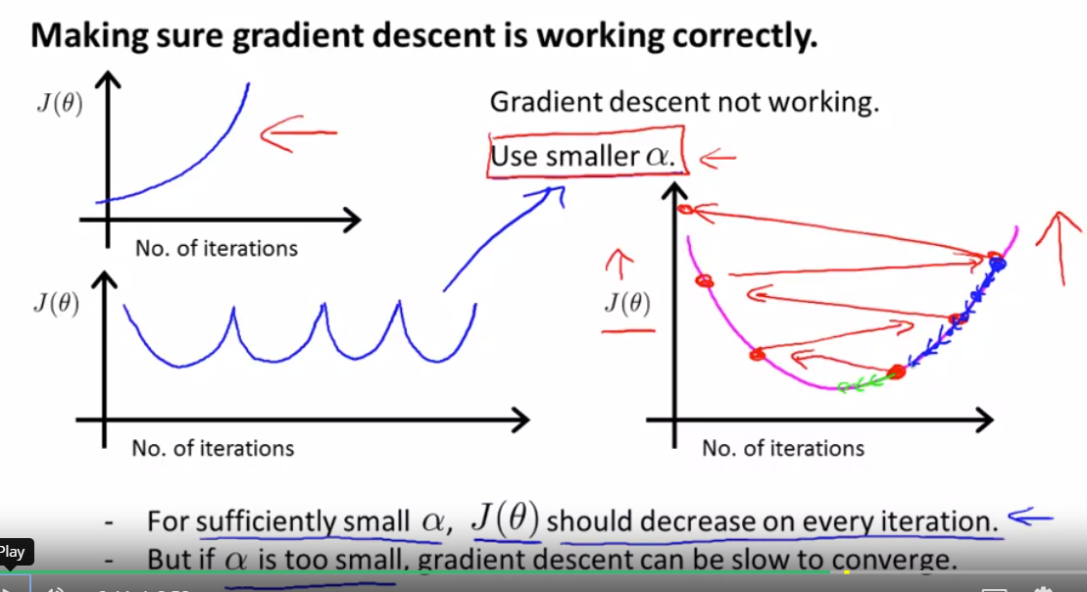

Feature and Polynomial Regression

You have a choice on what features to use and there is an algorithm to help you choose too!

## Computing Parameters Analytically

So far, we learn the gradient descent algorithm for linear regression to minimize J(Ɵ).

**Normal Equation,** a better way to solve for optimal values of Ɵ for some linear regression problems. A method to solve Ɵ analytically. Don’t need to feature scale if used normal equation.

# of features, n < 10,000 to use normal equation, if not use gradient descent

dJ(Ɵ)/dƟ = 0 to solve for Ɵ, if Ɵ in R

If you have more than one parameter Ɵ, you need to equate each partial derivative to 0 to find each parameter, Ɵ1, Ɵ2, etc.

**Construct a matrix with your training set!! Don’t forget to add another column for x0 = 1.**

**Ɵ = (XTX)-1XTy** **will give you the Ɵ to minimize cost function for linear regression**. Y, is housing price, x are factors that affect pricing.

**(XTX)-1** is inverse of matrix **XTX**, n x n matrix. In Octave, pinv(X’*X)*X’*y. p-inverse.

**Normal equation Non-invertibility**

**XTX** is non-invertible if singular or degenerate, thus cannot be computed.

Pinv, pseudoinverse, inv is inverse in MATLAB.

Pinv will let you compute Ɵ even though XTX is non-invertible.

XTX is non-invertible because:

* there are redundant features (linearly dependent), e.g.: 2 of the same variable w different units.
* there are too many features, m ≤ n (to fix: delete some features or use **regularization**).

M, # of training set, n, # of features. Ɵ is always **n + 1** dimensional because Ɵ0 = 1

**Matrix dimensions: X = m x (n+1), y = (m+1) x 1, Ɵ = (n+1) x 1**

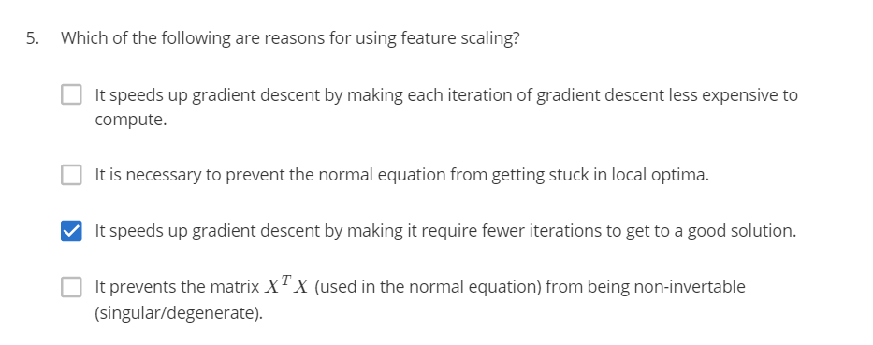

## Octave/MATLAB Tutorial

**Basic Operations**

**%** for comments

**~=** not equals to

Boolean is 1 for true, 0 for false

**&&** is AND Operation

**||** is OR operation

**xor(1,0)** = 1 Return the exclusive or of x and y. Outputs true only when inputs differ. For boolean expressions x and y, xor (x, y) is true if and only if one of x or y is true. Otherwise, if x and y are both true or both false, xor returns false.

**PS1(‘>> ‘)** - to change the prompt from octave-3.2.4.exe:11> to >>

Semicolon at the end of variable assignment suppresses output to print.

**disp(a);** - displays the value of a only. Without the variable.

a = pi

**disp(sprint(‘2 decimals: %0.2f’, a))** – to display string “2 decimals: 3.14”, %0.2f, substitute a into this position with 2 decimal places.

**format long** – to display many decimal places

**format short** – to print default number of decimal places

**A = [1 2; 3 4; 5 6]** to build a 3 by 2 matrix.

**ones(2,3)** - creates a 2 x 3 matrix with value 1.

**c = 2*ones(2,3)** – creates a 2 x 3 matrix with value 2.

**w = zeros(1,3)** – creates a 1 x 3 matrix with value 0.

**w = rand(1,3)** – creates a 1 x 3 matrix with random numbers between 0 and 1.

**w = randn(3, 3)** – creates a 3 x 3 matrix with Gaussian distribution, mean 0, s.d. = 1.

**hist(w)** to print histogram of variable w.

**hist(w, 10)** – to print histogram with 10 bins.

W = mean + sqrt(variance)*Gaussian

**w = -6 + sqrt(10)*(randn(1,10000))** - mean is -6, variance is 10, sd is sqrt(10)

**eye(4)** gives you 4 x 4 identity matrix. Diagonal matrix.

**help eye** – gives you documentation of the function eye.

**Moving data around**

**size(A)** returns a 1 x 2 matrix indicating dimension of matrix A.

**size(A, 1)** gives you the first element of the dimension, i.e.: number of rows.

**size(A, 2)** gives you the second element of the dimension, i.e.: number of columns.

**length(v)** gives you the size of the longest dimension of vector v. **applied to vectors only**, matrix is too confusing to apply.

**pwd** - **shows the current path octave is in.**

**c** – change directory, to change to D drive, **d:**

**ls** – list directories in your pwd

**load featuresx.dat** or **load(‘featuresx.dat’)** – to load featuresx.dat file into Octave.

**who** – shows variables that Octave has in memory currently.

**whos** – gives you detailed view of each variable in memory including dimension/size, bytes and class

**clear featuresx** – to clear featuresx variable from memory.

**v = priceY(1:10)** – v is a subset of vector priceY consisting first 10 elements of priceY

**save hello.mat v** – save v into a file called hello.mat. .mat files are in binary format, more compressed.

**clear** – deletes all variables in your workspace.

**save hello.text v –ascii** to save as ascii formatted text, human readable.

**A(3,2)** – index position 3rd row 2nd column of matrix A.

**A(2,: )** – extracts everything 2nd row of matrix A. : means every element along that row/column

**A(:,2)** – extracts everything 2nd column of matrix A.

**A([1 3], :)** – extracts everything from 1st and 3rd rows of matrix A.

**A(:, 2) = [10; 11; 12]** – to assign the 2nd column with a different set of numbers.

**A = [A, [100; 101; 102]]** - to append another column to matrix A.

**A(:)** - put all elements of A into a single column vector.

**C = [A B]** or **C = [A, B]** - concatenate matrix A on the left and B on the right to form matrix C.

**C = [A; B]** – concatenate matrix A on the top and B on the bottom to form matrix C.

**;** - usually means go to the next line.

**Computing on Data – May 13, 2020**

**A.* B** - elemental wise multiplication

**A * B** - matrix multiplication

**A .^2** - elemental squared

**1 ./v** - elemental reciprocal

Use . when two things to compute are matrices.

**log(v), exp(v)** - exponential, **abs(v)**, **-v**

**v + ones(length(v), 1) or v + 1** – add 1 to each element in the vector v

**A’** – transpose of matrix A; **(A’)’** – matrix A

**[val, ind] = max(a)** returns maximum value and index of the value in matrix A.

**Index in Octave starts at 1!**

**a < 3** - **elemental** comparison and returns 1 or 0 for Boolean

**find(a < 3)** – gives you elements that are less than 3

**A = magic(3)** – creates 3 x 3 magic square with random numbers, not useful for machine learning

**[r,c] = find(A >=7)** – find all elements in A greater or equal to 7, r for row, c for column for the element.

**sum(a)** – sum of all elements

**prod(a)** – product of all elements

**floor(a)** – rounds down all elements

**ceil(a)** – rounds up all elements

**max(rand(3), rand(3))** – takes element wise maximum of 2 random 3 x 3 matrices

**max(A, [], 1)** – takes column wise maximum of matrix A, 1 means to take the max among the first dimension of A

**max(A, [], 1)** – takes row wise maximum of matrix A, per row maximum

**max(A)** – takes per column maximum by default

**max(max(A))** – takes maximum of the max(A) row or column matrix

**A(:)** – turns a matrix into a vector (1 column)

**sum(A,1)** – sum per column of matrix A

**sum(A,2)** – sum per row of matrix A

To find diagonal sum, A .* eye(9), sum(sum(A.*eye(9)))

**flipud(eye(9))** to flip the matrix down, ud: up down

**pinv(A)** – give you inverse of A, pseudo inverse

**Plotting Data**

**plot(t,y1)**, t is x-axis, y1 is y-axis

Rewriting a new command will replace the plot in the window. To plot both functions at the same time

**plot(t, y1);**

**hold on;**

**plot(t,y2, ‘r’)**

**xlabel(‘time’)**

**ylabel(‘value’)**

**legend(‘sin’, ‘cos’)**

**title(‘my plot’)**

**cd ‘C:\Users…’;** change directory to save file.

**print –dpng ‘myplot.png’** to save this as a file

**close** to close the plot window

**figure(1); plot(t,y1);**

**figure(2); plot(t,y2);**

to plot two separate plots on two plot windows

**subplot(1,2,1);** to divide plot into a 1x2 grid, and access the first element

**plot(t,y1);**

**subplot(1,2,2);**

**plot(t,y2);**

**axis([0.5 1 -1 1])** set x-axis and y-axis range

**clf;** clears the figure

**imagesc(A), colorbar, colormap gray;** – plot matrix A into a n x n colors of grid in the plot window, inserts a colorbar and in greyscale. Carrying out 3 commands at the same time. Comma chaining of function calls, to put multiple commands on the same line.

**Control Statements – for, while, if statements, and functions**

**for i=1:10,**

**v(i) = 2^1;**

**end;**

indentation doesn’t matter, unlike Python, you can indent to make it cleaner but it doesn’t matter.

**indices=1:10;**

**for i=indices,**

**disp(i);**

**end;**

**i=1;**

**while i<= 5,  
 v(i) = 100;**

**i = i + 1;**

**end;**

**i=1;**

**while true,**

**v(i) = 999;**

**i = i + 1;**

**if i == 6,**

**break;** - break out of the while loop

**end;**

**end;**

**elseif** and **else** statement disp(‘The value is…’)

**exit** or **quit** to quit Octave

**Writing a function**

**functionname.m** is a function file in .m extension. Octave

Use WordPad instead of NotePad because it messes with spacing.

In the .m file,

**function y = squareThisNumber(x)**

**y = x^2;**

To call the function in Octave,

Change directory to where the .m file is stored.

**>squareThisNumber(5)**

To modify Octave search path

Addpath(‘C:\’) to add the specific path into the search path so that Octave can automatically find the path

Functions in Octave can return multiple values/arguments

In the function file,

**function [y1, y2] = squareAndCubeThisNumber(x)**

**y1 = x^2;**

**y2 = x^3;**

In Octave,

**[a, b] = squareAndCubeThisNumber(5)**

**Capitalization matters in Octave.**

**Vectorization – May 14, 2020**

MATLAB is one-indexed. So first element is 1, instead of 0 like Python. For loop starts with 1 instead of 0.

Gradient descent requires simultaneous update. Much more efficient to vectorize features.

# Week 3 –Logistic Regression May 17, 2020

*Welcome to week 3! This week, we’ll be covering logistic regression. Logistic regression is a method for classifying data into discrete outcomes. For example, we might use logistic regression to classify an email as spam or not spam. In this module, we introduce the notion of classification, the cost function for logistic regression, and the application of logistic regression to multi-class classification.*

*We are also covering regularization. Machine learning models need to generalize well to new examples that the model has not seen in practice. We’ll introduce regularization, which helps prevent models from overfitting the training data.*

## Classification and Representation

Binary Classification: 0 or 1 – negative/absence or positive/presence class. The designation is arbitrary, but this is the most common one.

Multiclass Classifcation: 0, 1, 2, 3

Regression is not suited for classification problem because prediction, h(x) can be >1 or <0. And classification is not a linear function.

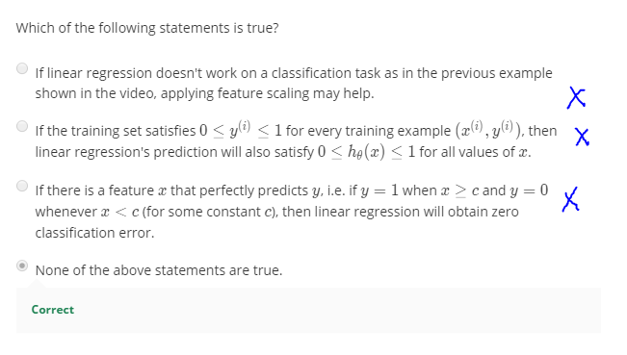

Logistic Regression is a classification algorithm. To limit predictions, h(x) to range from 0 to 1.

**Hypothesis Representation**

Linear regression: h(x) = ƟTx

Logistic Regression: uses sigmoid/logistic function **h(x) = g(ƟTx) when g(z) = 1/(1+ e-z),**

therefore, **h(x) = 1/(1+e- ƟTx)**

fit Ɵinto the function. **h(x) gives probability that y = 1 on input x.**

**h(x) = P(y=1|x; Ɵ)** probability that y = 1, given x, parameterized by Ɵ. **P(y=1|x; Ɵ) + P(y=0|x; Ɵ) = 1**

**Decision Boundary**

Positive if h(x) greater than or equal to 0.5 instead of just equal to.

**h(x) = g(ƟTx) ≥ 0.5 whenever ƟTx ≥ 0, so y = 1** Deduce from the logistic curve.

Decision Boundary is the line equation where **the h(x) = 0.5**. **a property of hypothesis/parameter** not a property of dataset/training set. Training set may be used to fit theta. Theta is what defines the decision boundary. H(x) indicates the probability that y is 1.

Decision boundaries can be non-linear, such as equation of circle.

## Logistic Regression Model

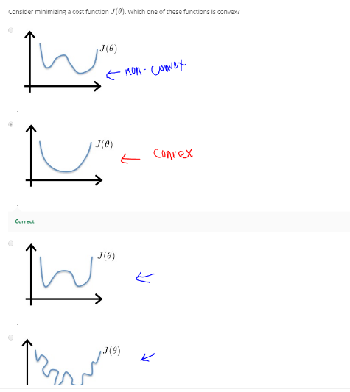**Cost Function**

Supervised algorithm to fit a logistic regression

How to choose theta automatically

J(Ɵ) should be a convex function, easier to achieve global minimum. Using linear regression cost function will make J(Ɵ) non-convex and hard to find global minimum. So need to come up with a different cost function.

Log is natural logarithmic, ln, with base e

Logistic Regression: $J\left(Ɵ\right)= \frac{1}{m}\sum_{i=1}^{m}{Cost(h_{Ɵ}\left(x^{i}\right),y^{i})}$

$$Cost\left(h_{Ɵ}\left(x\right), y\right)= \left\{\begin{aligned}-\log\left(h_{Ɵ}\left(x\right)\right) if y=1 \\ {-log⁡(1-h}_{Ɵ}\left(x\right)) if y=0\end{aligned}\right.$$

**Simplified Cost Function and Gradient Descent**

Condensed into one equation: $Cost\left(h_{Ɵ}\left(x\right), y\right)= -y\log\left(h_{Ɵ}\left(x\right)\right)-\left(1-y\right)log⁡(1-h_{Ɵ}\left(x\right))$

$$J\left(Ɵ\right)= -\frac{1}{m}[\sum_{i=1}^{m}{y\log\left(h_{Ɵ}\left(x^{i}\right)\right)+\left(1-y^{i}\right)\log\left(1-h_{Ɵ}\left(x^{i}\right)\right)}]$$

Derived from the principal of maximum likelihood estimation in stats to find theta efficiently for different models.

To fit parameters, minimize J(Ɵ) using gradient descent

$$\frac{∂}{∂Ɵ_{j}} J\left(Ɵ\right)= \frac{1}{m} \sum_{i=1}^{m}{[\left(h_{Ɵ}\left(x^{i}\right)-y^{i}\right)x_{j}^{i}]}$$

$$Ɵ_{j} := Ɵ_{j}- α\frac{∂}{∂Ɵ_{j}} J\left(Ɵ\right)$$

Algorithm is similar but h(x) is different for linear and logistic regression.

Feature scaling also applies to gradient descent for logistics regression.

Vectorized

$$h=g\left(XƟ\right)$$

$$J\left(Ɵ\right)=\frac{1}{m} (-y^{T}\log\left(h\right)-(1-y)^{T}log⁡(1-h)$$

$$Ɵ := Ɵ- \frac{α}{m}X^{T}\left(g\left(XƟ\right)-y\right)$$

$$Ɵ_{j} := Ɵ_{j}- ∝[\frac{1}{m}{\sum_{i=1}^{m}{(h_{Ɵ}(x^{i})}- y^{i}) x_{j}^{i}] }^{}$$

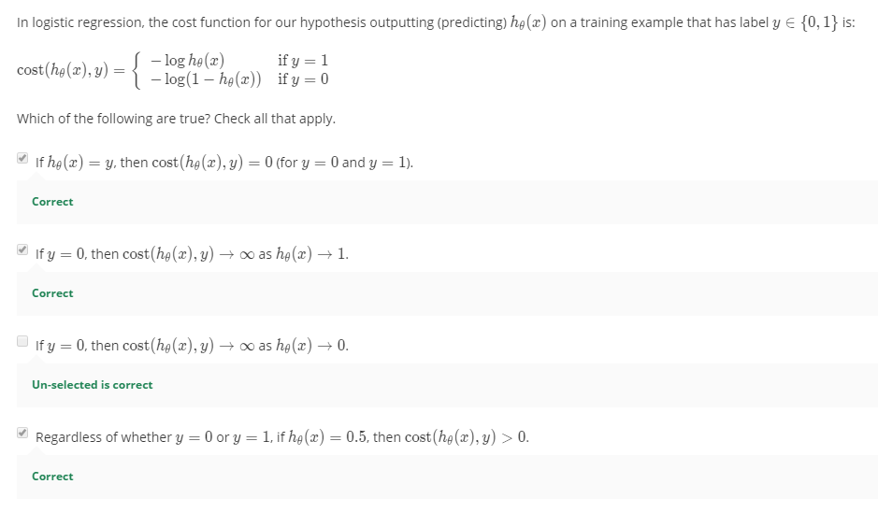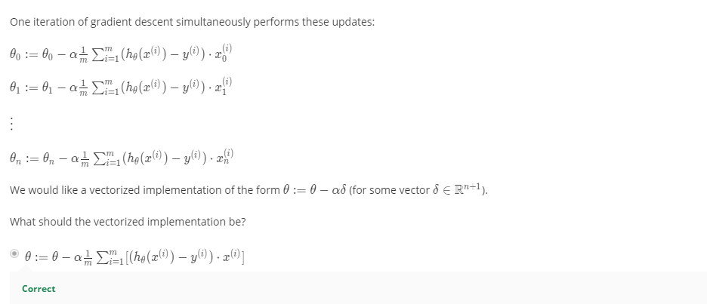

**Advanced Optimization**

Optimization algorithms:

* Gradient descent
* Conjugate gradient, BFGS, L-BFGS
  + More sophisticated algorithms learned in numerical computing
  + +: No need to pick α f- have an inner loop, line search algorithm, automatically search α even for every iteration, converge faster than gradient descent
  + -: More complex

**fminunc function** – function minimization unconstrained, to use the more advanced optimization algorithm, theta must be at least 2 dimension row vector or more to use this. Can be used on linear regression too. Be harder to debug because it’s opaque.

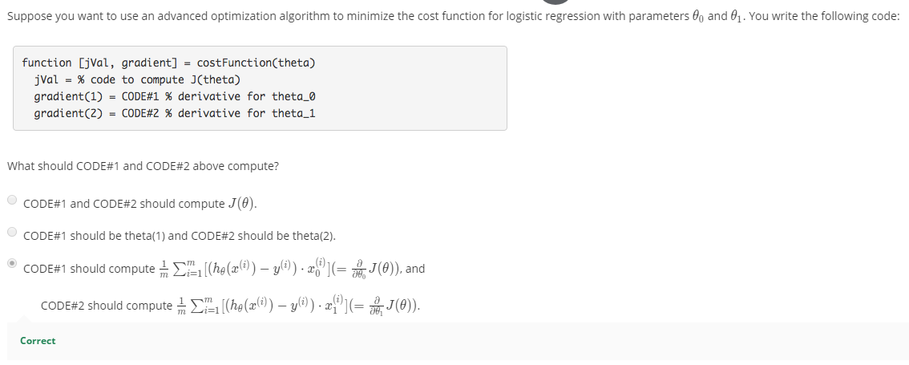

## Multiclass Classification

**One-VS-All or One-VS-Rest Classification**

For multiclass classification, y takes on multiple discrete values.

Turn this into binary classification for each y.

Class 1 with y = 1, other than class 1 with y = 0.

hƟ1(x) means prediction for class 1.

Train a logistic regression classifier hƟi(x) for each class i to predict the probability that y = i.

**To make prediction of a new input x, pick class i that maximizes hƟi(x) aka highest probability.**

If you have k classes, you have k binary logistic regression classifiers to train.

## Solving the Problem of Overfitting

**The Problem of Overfitting**

Regularization to reduce overfitting to get these algorithms work much better.

**Underfitting**, in other words, **high bias**.

**Just right.**

**Overfitting**, in other words, **high variance**. Not a good hypothesis when it can fit all data but fail to generalize to new examples.

An overfitting hypothesis on training set meant *it makes accurate predictions for examples in the training set, but it does not generalize well to make accurate predictions on new, previously unseen examples*.

To address overfitting:

1. Reduce # of features: select features to keep, model selection algorithm to help decide features to keep automatically. Downside is you are also throwing information that can be helpful.
2. Regularization: Keep all feature, but reduce the magnitude of Ɵj. Works well when we have a lot of feature contributing to predicting y.

**Cost Function**

Use a different cost function for regularization.

Regularization: small values for parameters will result into a simpler hypothesis that is less prone to overfitting. Let some Ɵ ~ 0.

Which parameters should we try to shrink?

In regularization, we modify cost function J to shrink all parameters. Add a regularization term to shrink every single parameter.

Only regularize from Ɵ1 to Ɵn instead of Ɵ0 by convention. Ɵ0 will not change much.

$$J\left(Ɵ\right)= \frac{1}{2m}[\sum_{i=1}^{m}{{(h}_{Ɵ}{(x^{i}})- y^{i})^{2}+ λ\sum_{j=1}^{n}{Ɵ_{j}^{2}]}}$$

λ, regularization parameter: controls a tradeoff between different goals. First goal/first term is to fit the training set well, second term/goal is to keep parameters small. To keep hypothesis simple to avoid overfitting.

** If λ is set to an extremely large value, the algorithm will result in underfitting, i.e.: fails to fit even the training set. We will penalize Ɵ’s very highly. All Ɵ will be close to 0 and became hƟ(x) = Ɵ0 becomes a flat line. So, underfitting, too strong of preconception/bias.

**The greater the λ, the smaller the Ɵ.**

**Regularized Linear Regression**

Regularize both algorithms gradient descent and normal equation. We don’t penalize Ɵ0 in regularization.

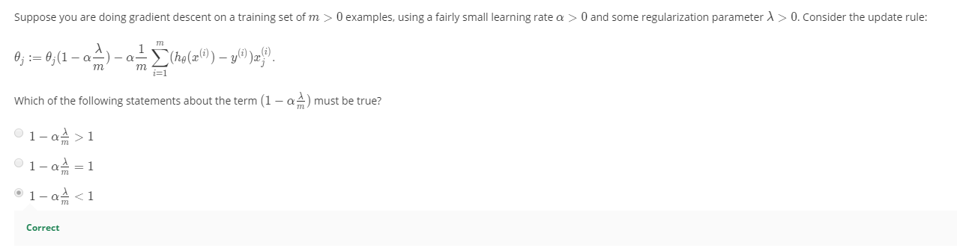

$Ɵ_{j }≔Ɵ_{j }\left(1-α\frac{λ}{m}\right)- α\frac{1}{m} \sum_{i=1}^{m}{{(h}_{Ɵ}{(x^{i}})- y^{i})x_{j}^{i}}$ where $1-α\frac{λ}{m}<1$

Non-invertibility

If # examples, m, is less than # features, n, XTX is non-invertible/singular/a degenerate matrix, inv() won’t work. Pinv() is not reliable.

In regularization, if λ > 0, the term will be invertible.

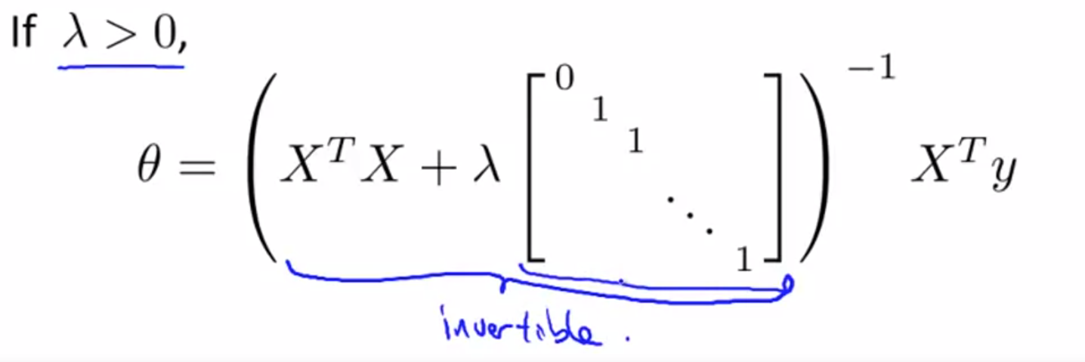

**Regularized logistic regression**

Regularized logistic cost function

$$J\left(Ɵ\right)= -\frac{1}{m}\left[\sum_{i=1}^{m}{y\log\left(h_{Ɵ}\left(x^{i}\right)\right)+\left(1-y^{i}\right)\log\left(1-h_{Ɵ}\left(x^{i}\right)\right)}\right]+ \frac{λ}{2m}\sum_{j=1}^{n}{Ɵ_{j}^{2} where Ɵ1…Ɵn}$$

Regularized gradient descent

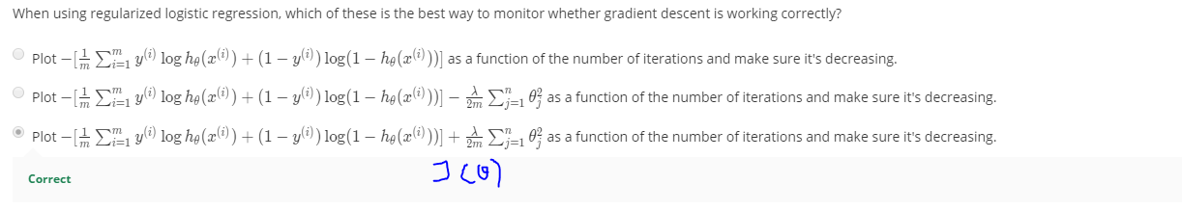

**Ɵ0 = 0 to exclude the bias feature. This is because Regularization puts a penalty on large (non-bias) theta values. This makes hypotheses less likely to overfit. The purpose of regularization is to reduce overfitting by making the weights smaller. Since large bias causes underfitting rather than overfitting, we don’t want to reduce the bias when we are overfitting. For this reason the “bias term” weights don’t participate in regularization.**

# Week 4 – Neural Networks: Representation May 25, 2020

*Welcome to week 4! This week, we are covering neural networks. Neural networks is a model inspired by how the brain works. It is widely used today in many applications: when your phone interprets and understand your voice commands, it is likely that a neural network is helping to understand your speech; when you cash a check, the machines that automatically read the digits also use neural networks.*

## Motivations

**Non-linear hypothesis**

Neural network, another learning algorithm.

Logistics regression works well for 2 features with many polynomial/quadratic combinations. Can be computationally expensive with a lot of features and can be overfitting. You can include subset of features. Can fit an ellipse but certainly cannot compute other classification more than that.

Dimension of feature space:

50 x 50 pixel images = 2500 pixels n = 2500, X = list of pixel intensity. Quadratic features (xi x xj) ~ 3M features

Greyscale range from 0 – 255

N = 7500 for RGB

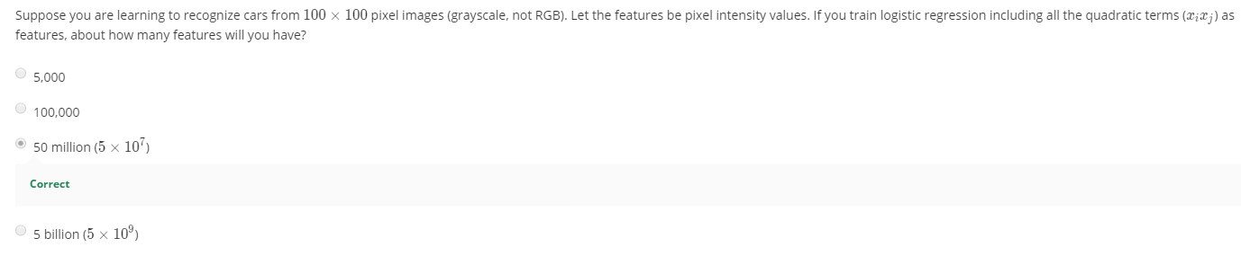

**Neurons and the brain**

Neural networks: Algorithm that try to mimic the brain.

Sensors can relearn new ways to learn things.

## Neural Networks - May 30, 2020

Model Representation

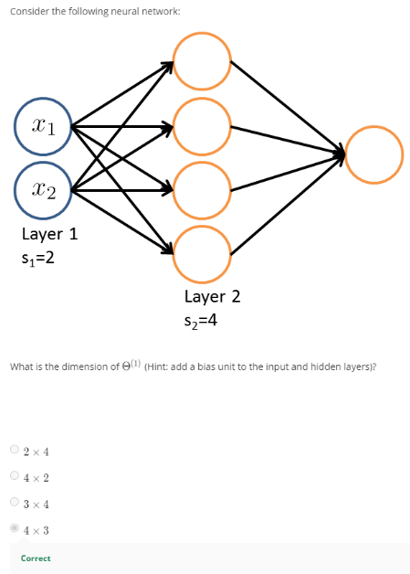Dendrite of a neuron is **input wire**, axon is **output wire**.

Model neuron as a logistic unit in computers. It is called an artificial neuron with a sigmoid/logistic activation function.

**X0 = 1**, is a bias unit. Ɵ is also the **weights/parameters** of the model.

Neural network is a group of different neurons strung together.

First layer of x is **input layer**, the final layer is **output layer** that has a neuron, layer in between is **hidden layer**.

aij is activation of neuron unit i in layer j. Activation is the value that is computed by and as output by a specific?? Is a sigmoid function computed in the function of the linear combination of theta. G(linear combination of theta Ɵ).

** If a network has sj units in layer j, sj+1 units in layer j + 1, then Ɵj will be of dimension **sj+1 x (sj+1)** bias nodes included. Output nodes don’t include bias nodes but the inputs will.

Each layer gets its own matrix of weights

**Forward propagation**:

**z(2) = Θ(1)**

**a(2) = g(z(2))**

Add bias feature in, a0(2)= 1.

**z(3) = Θ(2) a(2)**

**hΘ(x) = g(Ɵ101 + Ɵ111x1 + Ɵ121x2)**

**hΘ(x) = a(3) = g(z(3))**

Neural Network learning its own features

Network architectures: how neurons are connected

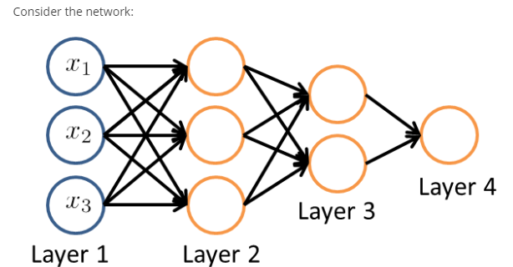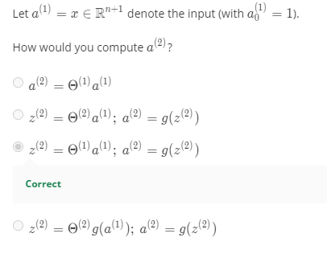

## Applications

**Neural Network to compute a logical function when x1 and x2 are binary**

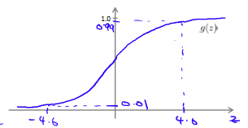AND, XOR, XNOR, OR function. negation function, NOT x1.

Come up with a truth table with all possibilities with different combinations of output of x. give some weightings to give the white columns the binary value.

Recall hΘ(x) is a logistic curve. Compute g(z) for **x1 XNOR x2**.

Truth table:

|  |  |  |  |  |  |  |
| --- | --- | --- | --- | --- | --- | --- |
| Input | | Hidden Layer 2 | | Output layer hΘ(x) |  |  |
|  |  | New x1, a1 | New x2, a2 | Compute w a’s |  |  |
| x1 | x2 | x1 AND x2 | (NOT x1) AND (NOT x2) | x1 XNOR x2 | x1 XOR x2 | x1 OR x2 |
| 0 | 0 | 0 | 1 | 1 | 0 | 0 |
| 0 | 1 | 0 | 0 | 0 | 1 | 1 |
| 1 | 0 | 0 | 0 | 0 | 1 | 1 |
| 1 | 1 | 1 | 0 | 1 | 0 | 1 |

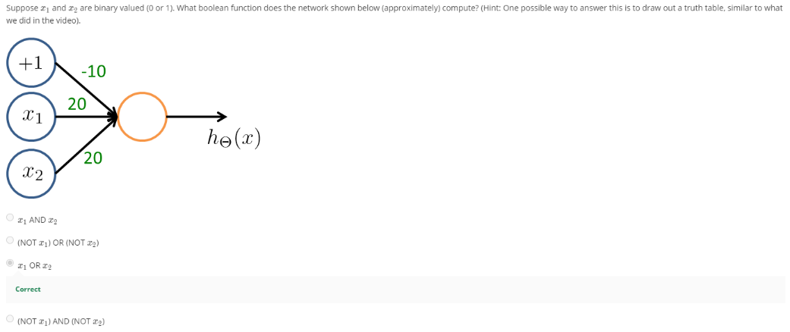

**Neural Network to compute complex non-linear hypothesis**

Put a large negative weight on the variable(s) to negate.

(NOT x1) AND (NOT x2) means this is only going to be 1 if x1 = 0 and x2 = 0. NOT x1 means x1 = 0.

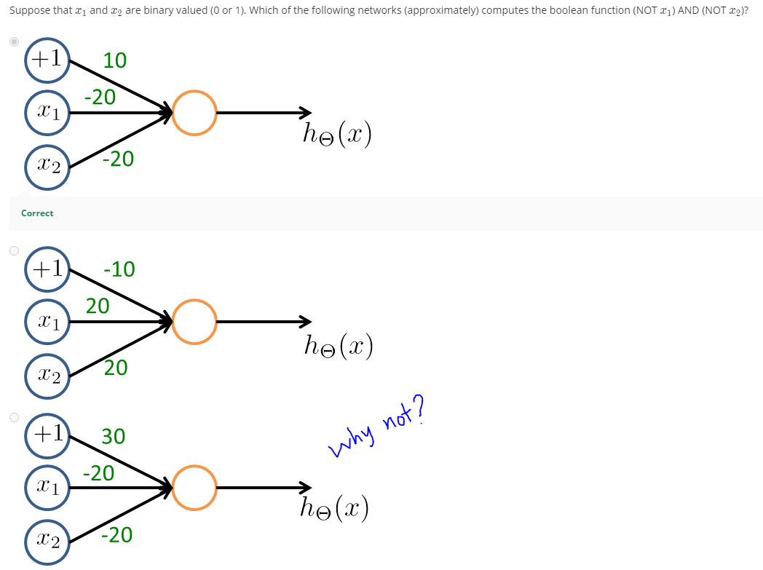

Logistic regression is a linear classifier, so cannot form more complex hypotheses

# Week 5 – Neural Networks: Learning

*In Week 5, you will be learning how to train Neural Networks. The Neural Network is one of the most powerful learning algorithms (when a linear classifier doesn't work, this is what I usually turn to), and this week's videos explain the 'backpropagation' algorithm for training these models. In this week's programming assignment, you'll also get to implement this algorithm and see it work for yourself.*

*The Neural Network programming exercise will be one of the more challenging ones of this class. So please start early and do leave extra time to get it done, and I hope you'll stick with it until you get it to work! As always, if you get stuck on the quiz and programming assignment, you should post on the Discussions to ask for help. (And if you finish early, I hope you'll go there to help your fellow classmates as well.)*

## Cost Function and Backpropagation June 6, 2020

**Cost Function**

One-Versus-All method only when there are equal to or greater than 3 output units. If there are 2 classes, we only need to use one output unit (binary) 1 or 0.

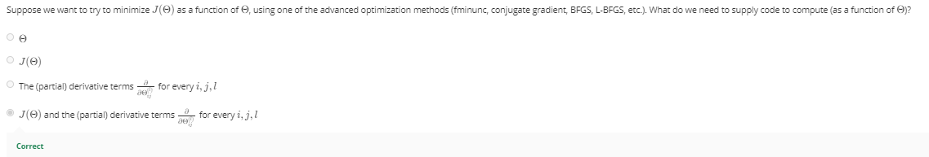

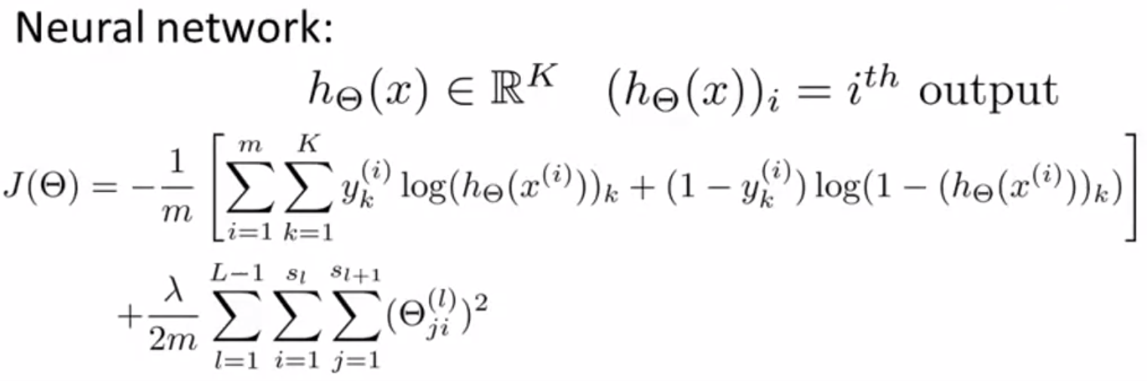

Backpropagation algorithm: A learning algorithm that fits the parameters of a neural network and minimizes the cost function given a training set.

To minimize J(Θ), we need to use gradient descent or advance optimization algorithms, we need code that inputs Θ that compute J(Θ) and partial derivative of J(Θ).

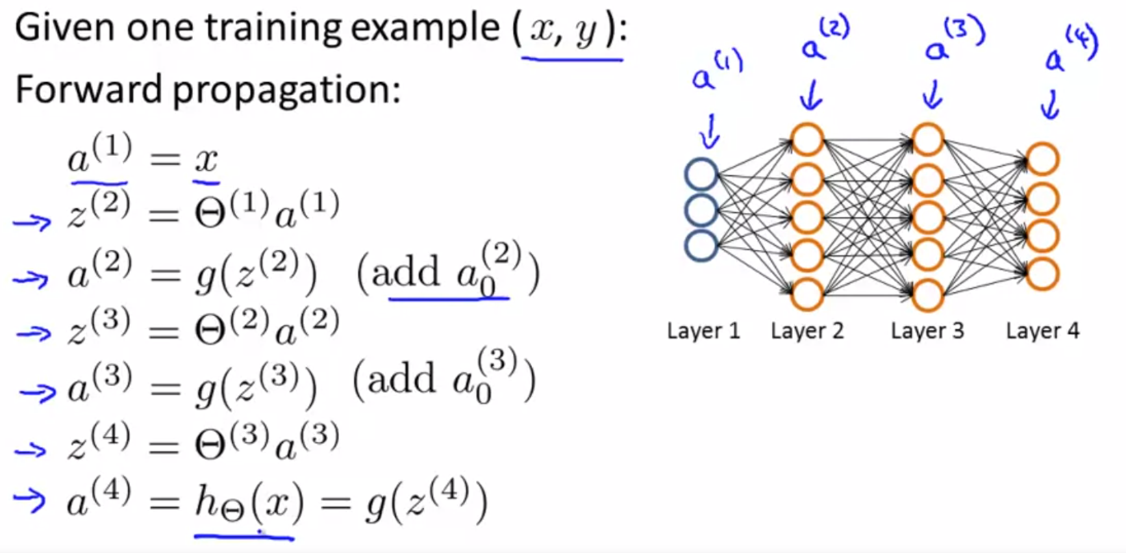

**Backpropagation** **Algorithm**

to compute derivatives. And have to do it in the backwards manner. Start from the last layer.

Need to determine the error of each node in each layer. The difference between the hypothesis and actual output.

Vectorized, for L = 4

**δ(4) = a(4) – y**

**δ(3) = (Θ(3))Tδ(4) .* g’(z(3)) = (Θ(3))Tδ(4) .* [a(3) .* (1-a(3))]**

**δ(2) = (Θ(2))Tδ(3) .* [a(2) .* (1-a(2))]**

No δ(1) because that is the input layer, has no error associated with it. No need to compute, if they are, they don’t end up being part of a calculation. Usually discarded.

Vectorized implementation:

Set **Δij(l)** = 0 for all l, i, j)

For loop from i = 1 to m,

A(1) = x(i)

Forward propagation to compute a(l), l = 2, 3, …, L

**δ(L) = a(L) – y(i) , δ(L-1), …, to δ(2)**

**Δ(l) := Δ(l) + δ(l+1)(a(l))T**

**Dij(l) := 1/m Δij(l) + λΘij(l) if j ≠ 0** D as an accumulator to add up our values to compute partial derivative.

**Dij(l) := 1/m Δij(l) if j = 0**. Because j = 0 is the bias term, don’t have regularization.

$$\frac{∂}{∂{}_{ij}^{(l)}} J\left(\right)= D_{ij}^{(l)}$$

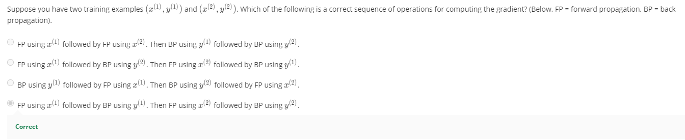

**Backpropagation Intuition**

**Revisit this video for clarity!!**

Forward propagation:

Z is the weighted sum of inputs of the input units, Θ

Compute sigmoid of logistic function on z to get the activation unit in a layer.

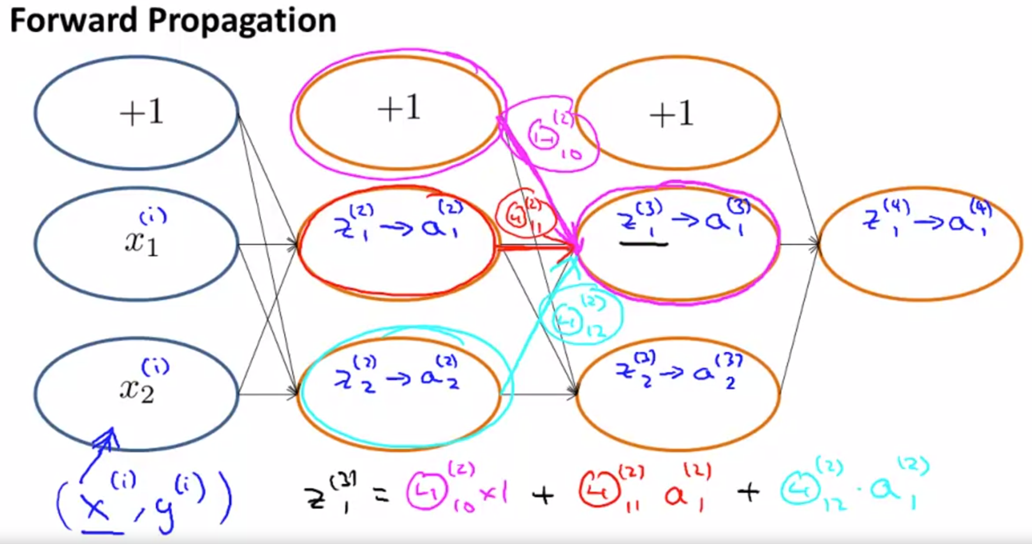

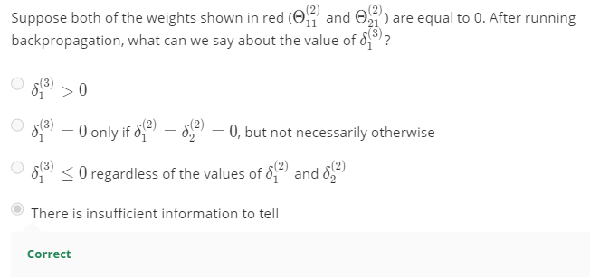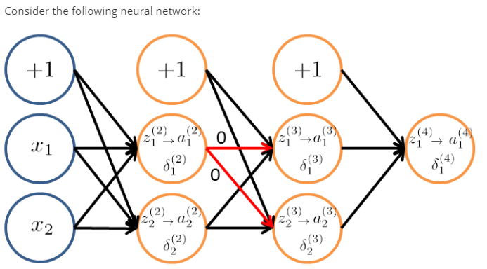

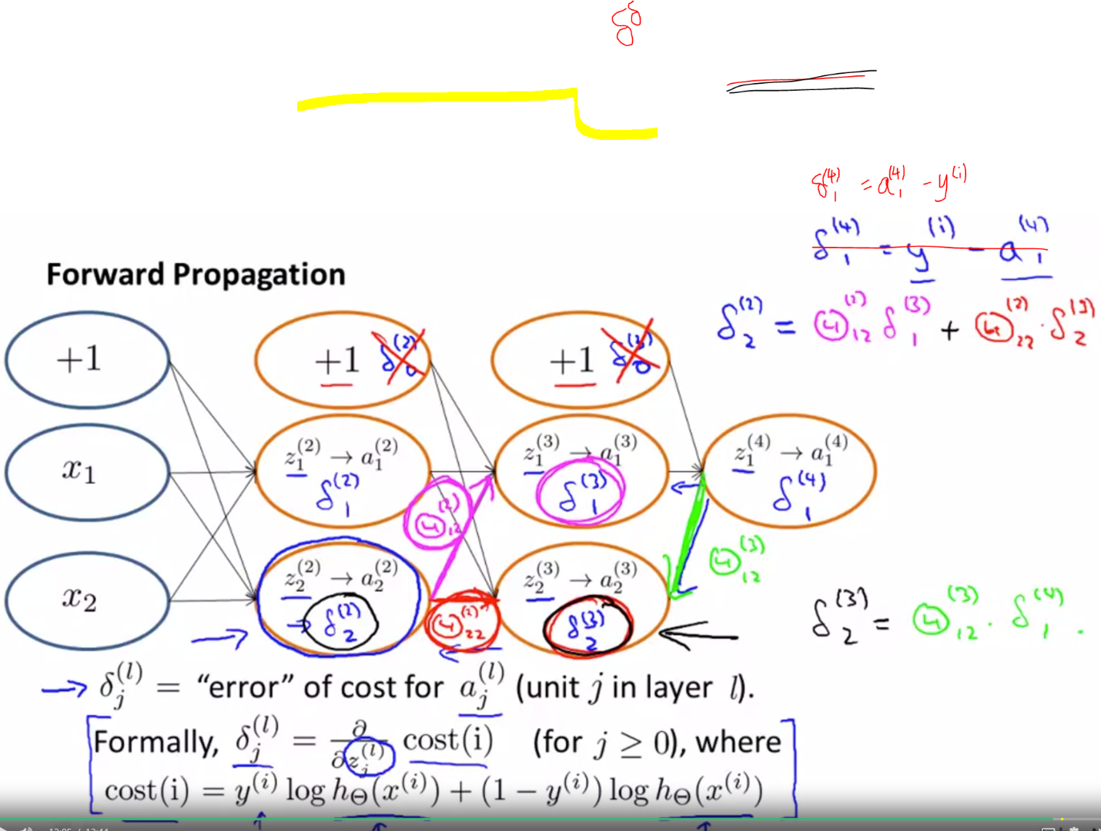

## Backpropagation in Practice

**Implementation Note: Unrolling Parameters**

For advanced optimization methods, they take gradient and theta as vectors. But in NN, Theta and D are matrices, need to unroll into vectors to be used in functions like fminunc.

The way you do that is you split Theta into a long vector.

To go back and forth from unrolled vectors to matrix:

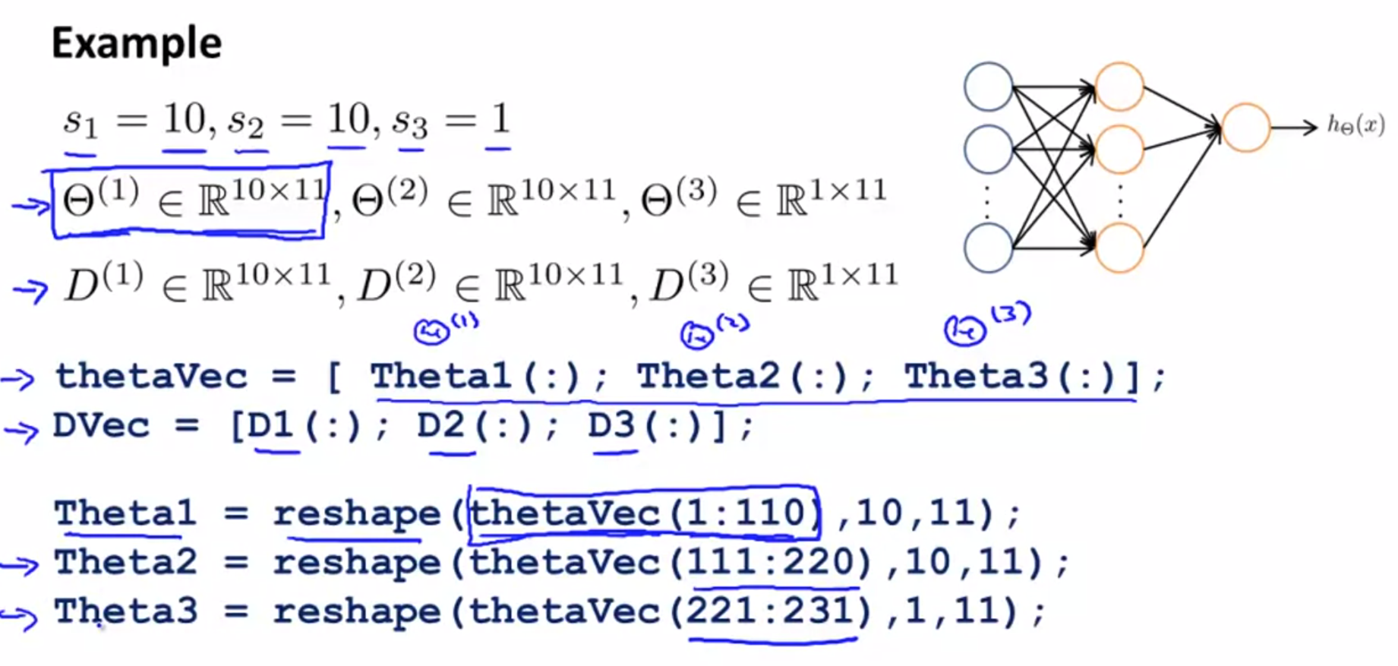

The first element of D2 starts on the 61st index and ends on the 71st index. There are 11 elements in total.

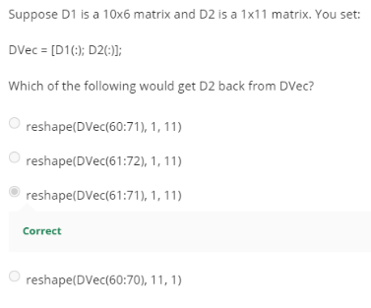

**Gradient Checking**

Ensure back prop implementation is correct and not buggy.

Compare the gradient you got from back propagation with the gradient you measured from 2 points around theta of interest.

2-sided difference in gradient is more accurate than 1-sided difference.

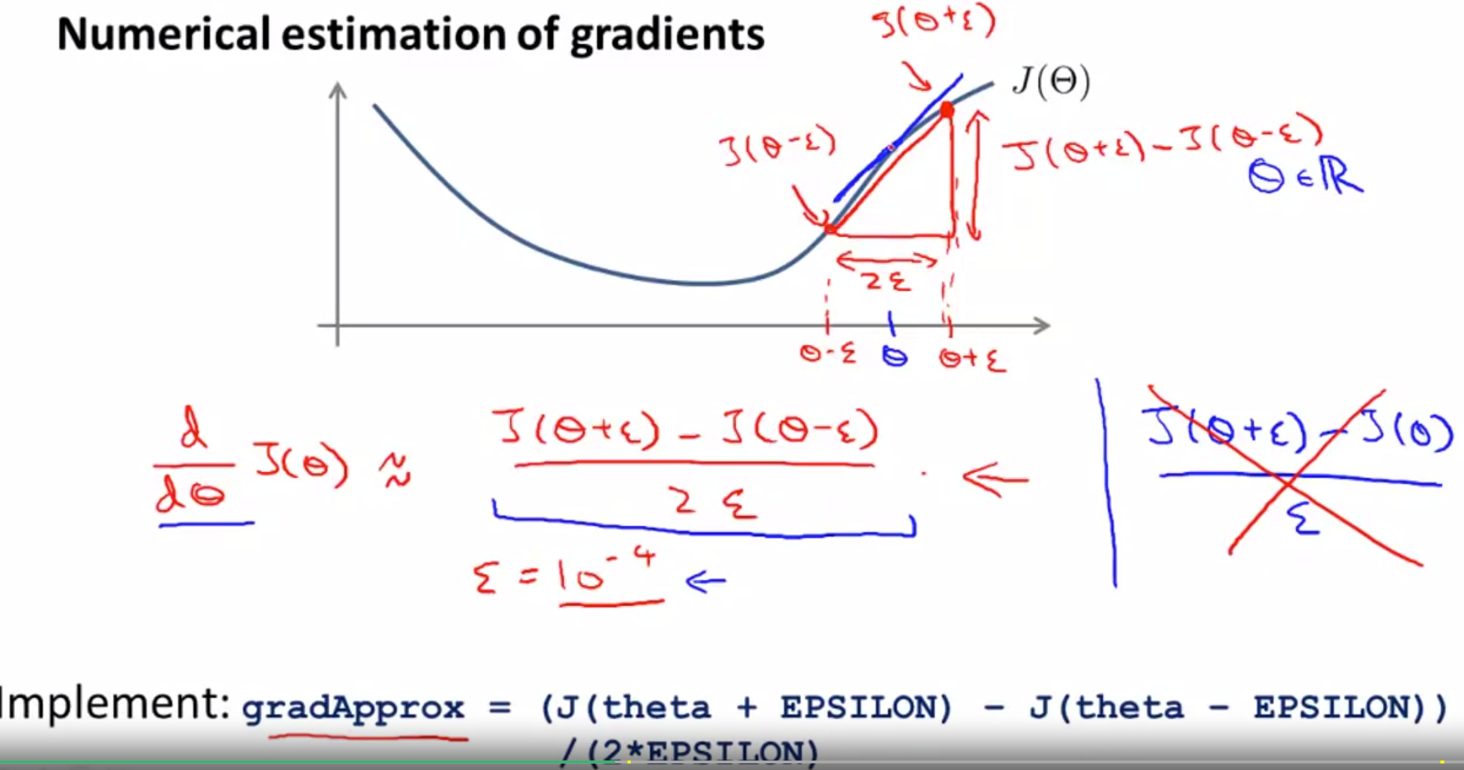

Compare gradApprox with DVec from backpropagation to ensure the optimization is correct.

After checking, turn off gradient checking code before training or it will be very slow.

Backpropagation algorithm is used during learning rather than numerical gradient computation method, gradApprox, because it is very slow.

**Random Initialization**

Need initial value of Θ.

Zero initialization: Initializing all zeros for logistic regression works, but doesn’t work for neural network. Because hidden units, a, and delta are going to be the same for all units in the same layer. – the symmetry weights problem, i.e.: all weights are the same.

**Symmetry breaking** by random initialization. Initialize Θ to be a random number between -ε and ε.

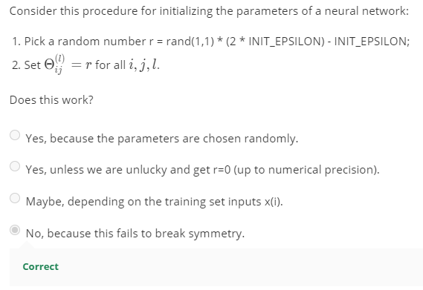If r is the same for all Θ, you face the same symmetry weights problem using zero initialization.

**Putting It Together – Training a NN**

1. Choose a network architecture
   1. Based on the dimension of features xi and number of classes.
   2. Reasonable default with 1 hidden layer, if >1 hidden layer, use same number of hidden units (more than # of inputs) in every layer (usually the more the better, but more expensive)
2. Randomly initialize weights
3. Forward propagation to get h(x) for any x
4. Compute cost function
5. Back propagation to compute partial derivative
6. Use gradient checking to compare derivative computed from backprop
7. Gradient descent or advanced optimization method with backprop to minimize cost function.

Cost function is non-convex, gradient descent and advanced optimization can get stuck at local minimum, not a big deal. Although not guarantee will find global minimum, usually the alogrithms do a very good job in minimizing cost function and get to a very good local minimum.

Backprop is trying to find the direction to the minimum point.

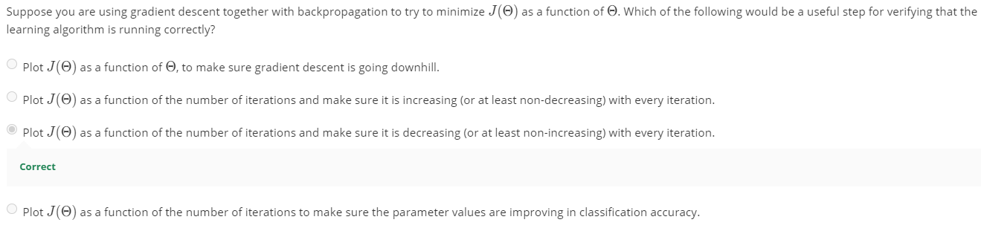

## Application of Neural Networks

**Autonomous Driving**

# Week 6a – Advice for Applying Machine Learning

*In Week 6, you will be learning about systematically improving your learning algorithm. The videos for this week will teach you how to tell when a learning algorithm is doing poorly, and describe the 'best practices' for how to 'debug' your learning algorithm and go about improving its performance.*

*We will also be covering machine learning system design. To optimize a machine learning algorithm, you’ll need to first understand where the biggest improvements can be made. In these lessons, we discuss how to understand the performance of a machine learning system with multiple parts, and also how to deal with skewed data.*

*When you're applying machine learning to real problems, a solid grasp of this week's content will easily save you a large amount of work.*

## Evaluating a Learning Algorithm – June 10, 2020

**Deciding What to Try Next**

When you test hypothesis on your test set, you get a lot of errors. What should you do next?

* Get more training examples (doesn’t always work)
* Try smaller set of features to prevent overfitting
* Try getting additional features
* Try adding polynomial features
* Try decreasing/increasing lambda (regularization parameters)

People pick by random and it’s time consuming. So use ML diagnostic to improve performance

**ML Diagnostic**: A test that you can run to gain insight on what is/is not working with a learning algorithm, and gain guidance as to how best to improve its performance. Takes time to implement, but good use of your time.

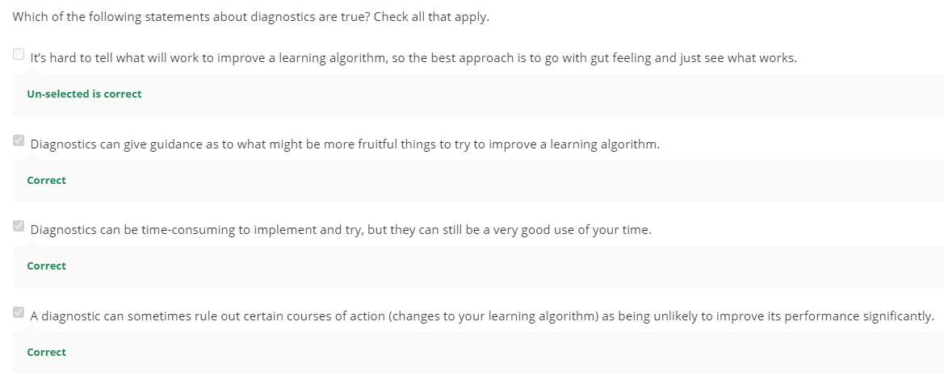

**Evaluating a Hypothesis**

Split data into two parts – randomized training set 70% and randomized test set 30%. Randomly sorted.



Determine the test set error and/or misclassification Error

**Model Selection and Train/Validation/Test Sets**

Choose the degree of polynomial for your hypothesis. You can calculate **cost function of test set** for each degree and see which has the minimum cost. But the hypothesis chosen is not fair for other examples because it is generalized for the test set.

What we’d do instead:

Split data into 3 sets – training set 60%, cross-validation (CV) set 20%, test set 20%. Use cross-validation set to pick the lowest cross-validation error/cost function to test the model. Use that on the test set.

Optimize Ɵ using training set for each polynomial degree. Find d with the least error using cross-validation set. Estimate the generalization error using the test set.

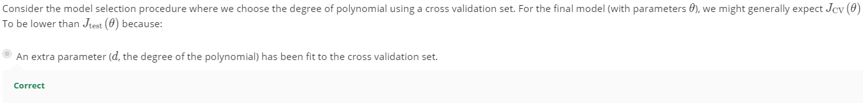

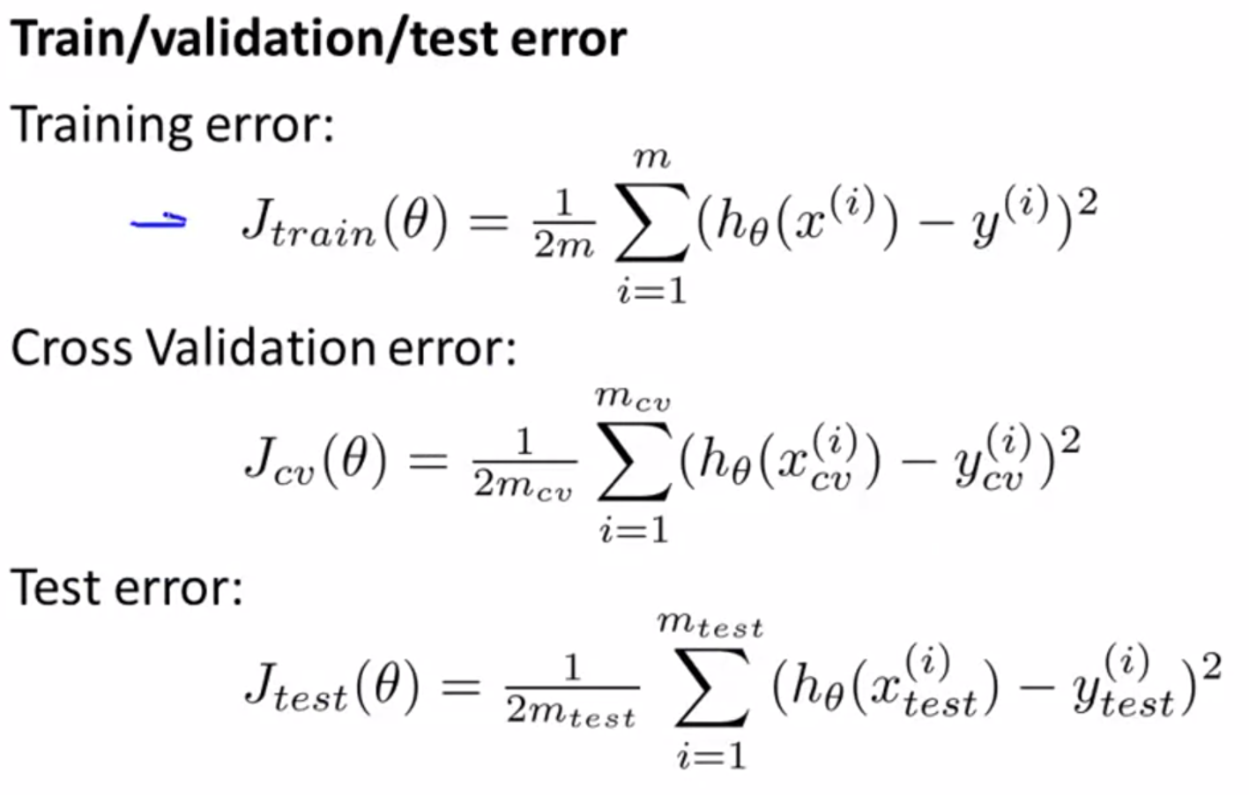

## Bias VS Variance

**Diagnosing Bias VS Variance**

Common problems in learning algorithm: high bias/underfitting or high variance/overfitting problem.

Plot J against degree of polynomial for train set, cross validation (cv) set, and test set

**VIP: Clues on your algorithm performance**

**Low degree of polynomial, high error – high bias, underfit for both train and CV set, high J_train J_train ~ J_CV**

**High degree of polynomial, high error – high variance, overfit, low J_train, J_train << J_CV**

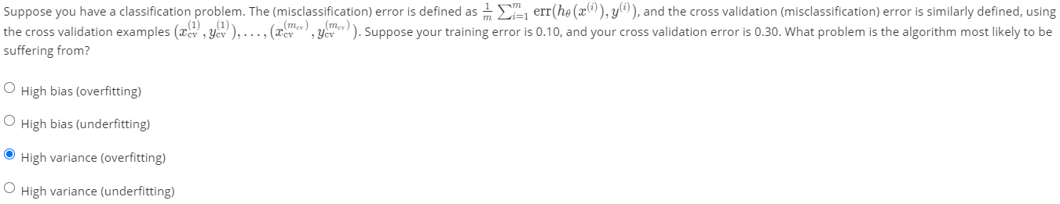

**Regularization and Bias/Variance**

Regularization to prevent overfitting

**Large lambda, high bias/underfit; small lambda, high variance/overfit.**

Pick a range of lambda, minimize cost function (w regularization) and come up with Ɵ. Use each Ɵ from each lambda to determine lowest cost function for CV set (w/o regularization) of all.

Small lambda, (fit training set well, cuz not regularizing, the regularization term goes away), overfitting data, small J_train, but large J_CV because the theta is used to fit the train set but not the CV set, so won’t fit CV set too well.

Large lambda, high bias, large J_train, large_CV, underfitting

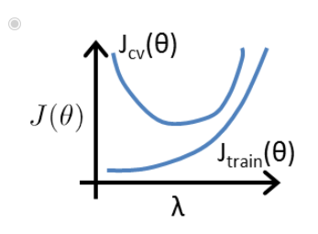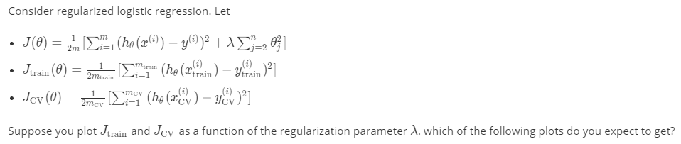

**Learning Curves**

Plot J_train and J_cv against m (training set size) – pick a smaller m to plot.

When m increases, J_train increases, harder to fit all training examples perfectly.

When m increases, J_cv is high, dataset that is not learned before, don’t generalize well and plateau once you reached a certain m that gives you the best fit.

If a learning algorithm is suffering from high bias, more training data will not help.

If a learning algorithm is suffering from high variance, more training data will help, to close up the gap between J_cv and J_train. (J_cv > J_train)

Plot the learning curves to improve the algorithm.

Debugging a Learning Alogrithm

|  |  |
| --- | --- |
| Options | What it is good for |
| Get more training examples | Fix high variance |
| Try smaller set of features | Fix high variance |
| Get additional features | Fix high bias |
| Add polynomial features | Fix high bias |
| Decrease lambda – easy to implement | Fix high bias |
| Increase lambda – easy to implement | Fix high variance |

A model without regularization (λ = 0) fits the training set well, but does not generalize.

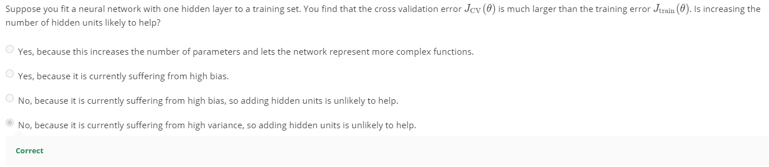

**Models with high bias are not complex enough for the data and tend to underfit, while models with high variance overfit to the training data.**

**Overfitting causes the cost on the training set to decrease, but the cost on the validation set to increase.**

# Week 6b – Machine Learning System Design

*To optimize a machine learning algorithm, you’ll need to first understand where the biggest improvements can be made. In this module, we discuss how to understand the performance of a machine learning system with multiple parts, and also how to deal with skewed data.*

## Building a Spam Classifier – June 16, 2020

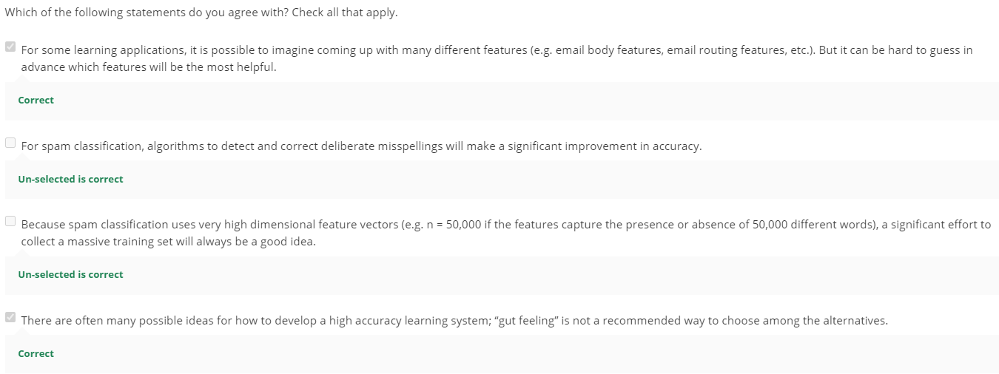

**Error Analysis**

**Recommended Approach for spam classifier:**

1. Implement a simple (quick & dirty) algorithm, max 24 hours and test on **CV data**
2. Plot learning curves to diagnose high bias/high variance
3. Error Analysis: analyze data that the algorithm made errors on to find trend.

Phishing – try to steal your passwords

Stemming software looks at the first few characters of the word to determine if it’s the same word. Evaluate algorithm on cross validation set with or without stemming. the process of treating the same word with different forms.

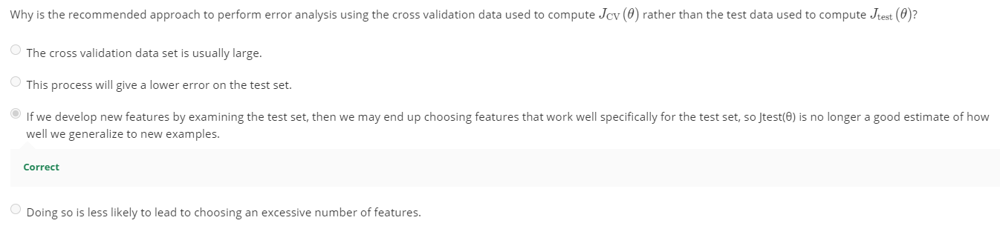

## Handling Skewed Data

**Error metrics for skewed classes**

Skewed classes – one class has way more data than another.

$$Accuracy= \frac{\# true pos+\# true neg}{total examples}$$

$$Precision= \frac{\# true positives}{\# predicted positives} = \frac{\# true pos}{true pos+false pos}$$

$$Recall= \frac{\# true positives}{\# actual positives} = \frac{\# true pos}{true pos+false neg}$$

Accuracy is not a good measure with skewed data.

The higher the precision/recall the better.

Set y = 1 for rare cases like cancer detection.

Reminder: Logistic regression, h(x) gives you the probability of y = 1 and y = 0.

For cancer diagnosis,

You want to be more confident before concluding the patient has cancer. Instead of half-half probability. You only predict y = 1 if there is more than 0.9 probability and y = 1 if less than 0.9. This leads to higher precision (more # true pos) and lower recall (higher # actual pos).

To avoid false negatives, can lower the probability to say 0.3. Higher recall, lower precision (because you are being conservative by lowering the probability).

There is tradeoff between precision and recall depending on the threshold you choose.

Compute **F1 score** helps you to decide which algorithm/threshold gives you a good precision and recall on skewed data.

$F Score=2\frac{P*R}{P+R}$ choose the algorithm with highest F Score. F score ranges from 0 to 1.

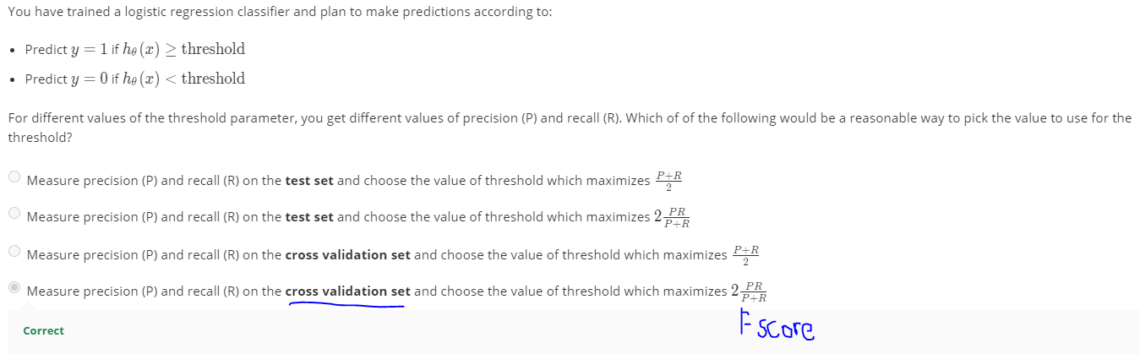

## Using Large Data Sets

The more the data, the higher the accuracy for that algorithm, true in some cases.

A learning algorithm (regression/neural network) with many parameters/features (will address the bias problem). A large training set will address the variance problem. You get low bias and low variance learning algorithm – leads to small J_train and J_train ~ J_test, so J_test will be small too.

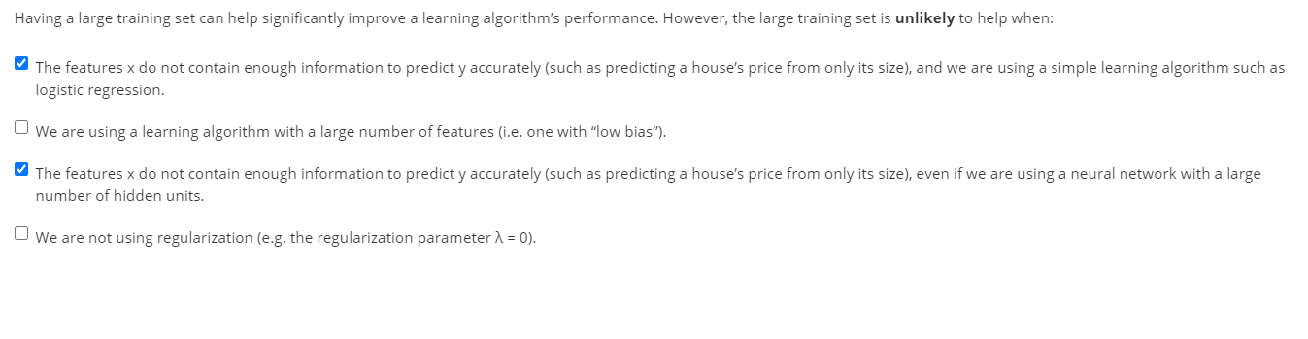Formulas Implementation

**Linear Regression**

* Non-regularized
  + Cost function
 $$J\left(Ɵ_{0},Ɵ_{1}\right)= \frac{1}{2m}\sum_{i=1}^{m}{{\left(h_{Ɵ}\left(x^{i}\right)- y^{i}\right)}^{2}}= \frac{1}{2m}\sum_{i=1}^{m}{{\left(Ɵ^{T}\left(x^{i}\right)- y^{i}\right)}^{2} }$$

 + Gradient descent
 $$Ɵ_{j} := Ɵ_{j}- \frac{α}{m} \sum_{i=1}^{m}{[\left(h_{Ɵ}\left(x_{i}\right)-y\right)x_{i}]}$$

 + Hypothesis
 $$h_{Ɵ}\left(x\right)= Ɵ_{0}+ Ɵ_{1}x_{1}+ Ɵ_{2}x_{2}+…+ Ɵ_{n}x_{n} {= Ɵ}^{T}X$$

 + Normal equation
$$Ɵ=(X^{T}X^{-1})X^{T}y$$

* Regularized
  + Cost Function
 $$J\left(Ɵ\right)= \frac{1}{2m}[\sum_{i=1}^{m}{{(h}_{Ɵ}{(x^{i}})- y^{i})^{2}+ λ\sum_{j=1}^{n}{Ɵ_{j}^{2}]}}$$

 + Gradient descent

* + Normal Equation

$If λ>0, Ɵ=(X^{T}X+ λ[\begin{matrix}0 & 0 & 0 & 0 \\ 0 & 1 & 0 & 0 \\ 0 & 0 & ⋱ & 0 \\ 0 & 0 & 0 & 1\end{matrix}])^{-1}X^{T}y$; matrix is of size (n+1) x (n+1)

**Logistic Regression**

* Non-regularized
  + Cost function
 $$J\left(Ɵ\right)= -\frac{1}{m}[\sum_{i=1}^{m}{y\log\left(h_{Ɵ}\left(x^{i}\right)\right)+\left(1-y^{i}\right)\log\left(1-h_{Ɵ}\left(x^{i}\right)\right)}]$$

 + Gradient descent
 $$Ɵ_{j} := Ɵ_{j}- α[\frac{1}{m} \sum_{i=1}^{m}{[\left(h_{Ɵ}\left(x^{i}\right)-y^{i}\right)x_{j}^{i}]}]$$

 + Prediction/Hypothesis
$$h_{Ɵ}\left(x\right)=g\left(Ɵ^{T}x\right), g\left(z\right)= \frac{1}{1+ e^{-z}}$$

* Regularized
  + Cost function

$$J\left(Ɵ\right)= -\frac{1}{m}\left[\sum_{i=1}^{m}{y\log\left(h_{Ɵ}\left(x^{i}\right)\right)+\left(1-y^{i}\right)\log\left(1-h_{Ɵ}\left(x^{i}\right)\right)}\right]+ \frac{λ}{2m}\sum_{j=1}^{n}{Ɵ_{j}^{2} where Ɵ1…Ɵn}$$

Did not regularize theta_0

* + Gradient descent

$$Ɵ_{j} := Ɵ_{j}- ∝[\frac{1}{m}\sum_{i=1}^{m}{{(h}_{Ɵ}\left(x^{i}\right)- y^{i}) x_{0}^{i}} when j= 0$$

$$Ɵ_{j} := Ɵ_{j}- ∝[\frac{1}{m}{\sum_{i=1}^{m}{(h_{Ɵ}(x^{i})}- y^{i}) x_{j}^{i}+ \frac{λ}{m} Ɵ_{j}] }^{} when j= 1… n$$

**Neural Network**

* Cost Function
  + Non-regularized

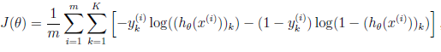

* + Regularized

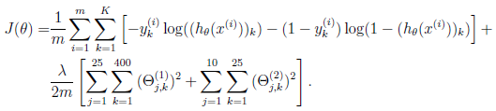

* Forward and backward propagation to minimize cost function
  + Forward propagation



* + Back propagation

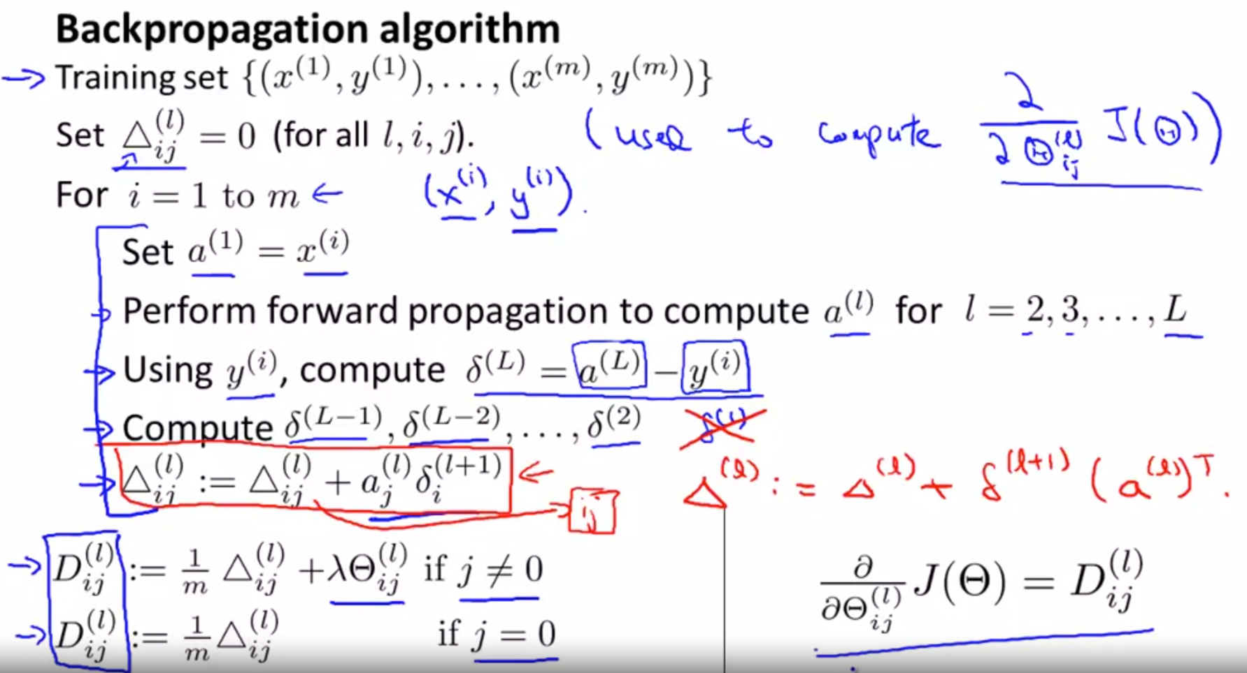

**Error Metrics**

$$Precision= \frac{\# true positives}{\# predicted positives} = \frac{\# true pos}{true pos+false pos}$$

$$Recall= \frac{\# true positives}{\# actual positives} = \frac{\# true pos}{true pos+false neg}$$

$$F Score=2\frac{P*R}{P+R}$$

# Useful Charts

